Part Number(s):
Hood, Fenders & Mirror Backs (if necessary)

Kit Contents
Item # | Quantity Reqd. | Description
1 | 1 | Hood Protective Film
2 | 1 | Front Fender Protective Film (DS)
3 | 1 | Front Fender Protective Film (PS)
4 | 1 | Mirror Protective Film (DS)
5 | 1 | Mirror Protective Film (PS)
6 | 1 | Care Card
Hardware Bag Contents
Item # | Quantity Reqd. | Description
1 | None
Additional Items Required For Installation
Item # | Quantity Reqd. | Description
1 | None
Recommended Tools
Personal & Vehicle Protection | Notes
None
Special Tools | Notes
Squeegee | 4” 3M™ Orange Applicator #71607  Optional:  4” 3M™ Black Applicator #05517 (approved for small areas around corners and crevices only)
Installation Tools | Notes
Spray Bottles
Pump Sprayer
Towel | Wypall® L40 All-Purpose Wipers
“T” Shirt Material | Supplied by CTC Supplies
Water Blade | 12” California® Water Blade
Dropper | Measures ml
Heat Gun
Special Chemicals | Notes
Wetting Agent | Johnson’s® Baby Shampoo(5 ml to 64oz. of water)
White Vinegar | Vinegar Solution used to enhance adhesive  (24 oz. of White Vinegar to 8 oz. of water)

Recommended Sequence of Application
Item # | Accessory
1 | Hood Protective Film
2 | Front Fender Protective Film (PS)
3 | Front Fender Protective Film (DS)
4 | Mirror Protective Film (DS)
5 | Mirror Protective Film (PS)
6 | Care Card
*Mandatory
Vehicle Service Parts (may be required for reassembly)
Item # | Quantity Reqd. | Description
1
2
3
Legend
STOP: Damage to the vehicle may occur. Do not proceed until process has been complied with.
OPERATOR SAFETY: Use caution to avoid risk of injury.
CAUTION: A process that must be carefully observed in order to reduce the risk of damage to the accessory/vehicle and to ensure a quality installation.
TOOLS & EQUIPMENT: Used in Figures calls out the specific tools and equipment recommended for this process.
REVISION MARK: This mark highlights a change in installation with respect to previous issue.
SAFETY TORQUE: This mark indicates that torque is related to safety.

Care must be taken when installing this accessory to ensure damage does not occur to the vehicle. The installation of this accessory should follow approved guidelines to ensure a quality installation.

These guidelines can be found in the "Accessory Installation Practices" document.

This document covers such items as:-
- Vehicle Protection (use of covers and blankets, cleaning chemicals, etc.).
- Safety (eye protection, rechecking torque procedure, etc.).
- Vehicle Disassembly/Reassembly (panel removal, part storage, etc.).
- Electrical Component Disassembly/Reassembly (battery disconnection, connector removal, etc.).

Please see your Toyota/Lexus/Scion dealer for a copy of this document.

1. Installation Environment
- To ensure the best results during an installation, set up an installation area that is safe and clean. The following items should be considered when selecting an area for installation:

- Installation should be performed in an ambient temperature from 45° Fahrenheit to 95° Fahrenheit. Adjust the wetting solution according to the ambient temperature. The following is stated for the 64 oz. wetting agent.
  - 45 º F - 65 º F = 4 ml Baby Shampoo
  - 65 º F - 75 º F = 5 ml Baby Shampoo
  - 75 º F - 85 º F = 6 - 7 ml Baby Shampoo
  - 85 º F - 95 º F = 7 - 8 ml Baby Shampoo

- Avoid installing in direct sunlight or extreme heat environment.

- Avoid installing material when the vehicle surface is over 90° Fahrenheit.

- Do not attempt to apply film during windy conditions.
- Keep the installation area free of dust, grease, or other small particles that can become airborne, i.e. wax dust, paint overspray, etc.
- The installation area must be well lit.

2. Vehicle Surface Preparation
- Before beginning any installation, the installer should perform the following steps to prepare the vehicle’s surface:

- Remove the vehicle wrap-guard material from application areas.

- Wash / clean the application surface thoroughly

- Remove any contaminations such as grease, oil, wax, dirt, bug residue, or road tar with approved VDC cleaner, followed by approved VDC window cleaner

- Inspect painted surfaces for existing damage or for fresh, loose, and/or scratched paint. It is recommended that any existing damage be repaired before installation.

- Clean the vehicle using Baby Shampoo Solution and a towel.

- Spray the vehicle with Baby Shampoo Solution generously and remove with a California® Water Blade.

3. Removing Film Material from Liner
- Check the pattern accuracy with the vehicle. Make sure all necessary pieces are present.

- Before handling the film, make sure that hands are clean. Then proceed to spray hands with the wetting agent to prevent transfer of fingerprints to the material. Keep hands wet throughout the install procedure.

- Remove material from liner. Continue to spray material with the wetting agent to prevent the adhesive side from sticking to itself. Keep hands wet.

4. Hood Installation Procedure
- Align the driver side outer edge of the piece where the hood meets the fender. Remove the water from beneath the material with the squeegee on the outer edge using approx. ¾ of the squeegee width.

- Apply only enough tension to allow for the proper alignment to the bottom inside corner of the vehicle panel. Maintain the proper alignment of the lower edge and the bottom corner while applying tension. Spray the adhesive side of the material with the Vinegar Solution and tack down the area using approx. ¾ of the squeegee width.

- Next apply enough tension to move across the lower edge of the panel to allow for the proper placement for the opposite side. While holding the tension with one hand, spray the vinegar solution in the area of the outer edge to ensure adhesion and placement. Replace the film and tack the area down with the squeegee while still holding the tension with the other hand.

- Apply only enough tension to allow for the proper alignment to the bottom inside corner of the vehicle panel. Maintain the proper alignment of the lower edge and the bottom corner while applying tension. Spray the adhesive side of the material with the Vinegar Solution and tack down the area using approx. ¾ of the squeegee width.

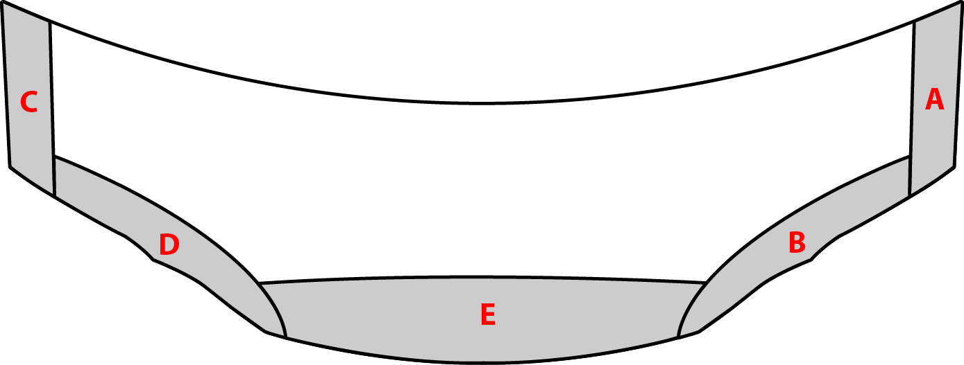
- Return to the lower leading edge. Spray the Vinegar Solution lightly on the very edge and lightly bump the material down to the proper alignment. Remove the water from this leading edge using approx. ¾ of the squeegee width. At this point an outline of the tacked material should form, leaving only the upper center of the film free.

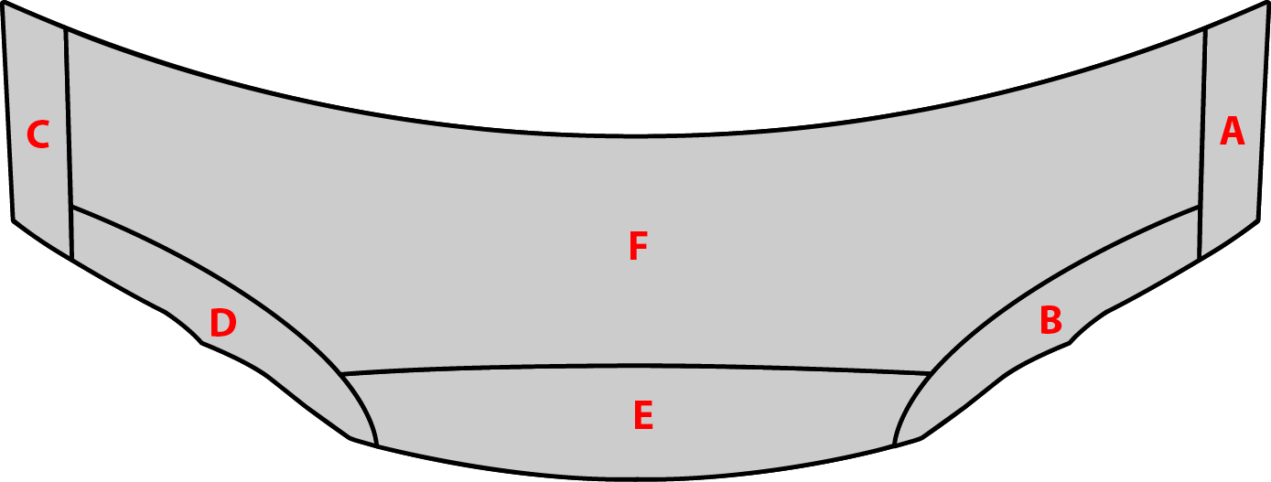
- Use upward and outward strokes with the squeegee to remove the remaining water from beneath the material. The water will leave from beneath the material only out the top edge of the piece. Never attempt to force the water back through an area that has already been tacked to prevent distortion of the clarity. Use a triangular pattern to remove the water from the middle and make sure no water or air remains beneath the film.

- Check the surface for bubbles or any other defects before continuing.

Seal all edges.
- This will be necessary after each individual piece. With the “T” shirt material wrapped around the hand, apply heat with the heat gun from 6 to 8 inches away from the vehicle panel. Angle the heat gun to heat the glue side of the material as opposed to the clear coat side. First, apply heat, and then wipe the material edge down with the “T” shirt wrapped hand. The film will be very pliable so take care to not distort the film. This process should be applied to the entire outer edge of the piece to seal the piece completely.

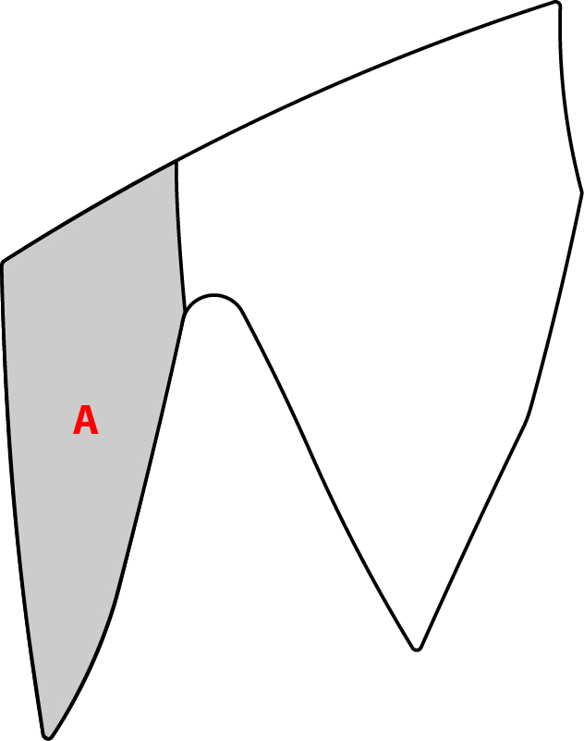
6. Front Fender Installation Procedure
- Line up the front fender with the lower corner that meets the headlight. Squeegee the lower portion to the top edge of the piece to where it aligns with the top edge of the hood piece. Be sure to keep edges within tolerance.

- Align and tack downward toward the lower corner. Apply Vinegar Solution on the lower corner as needed.

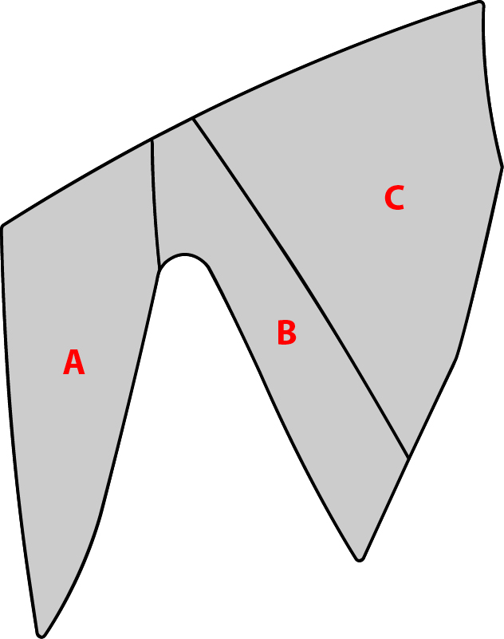
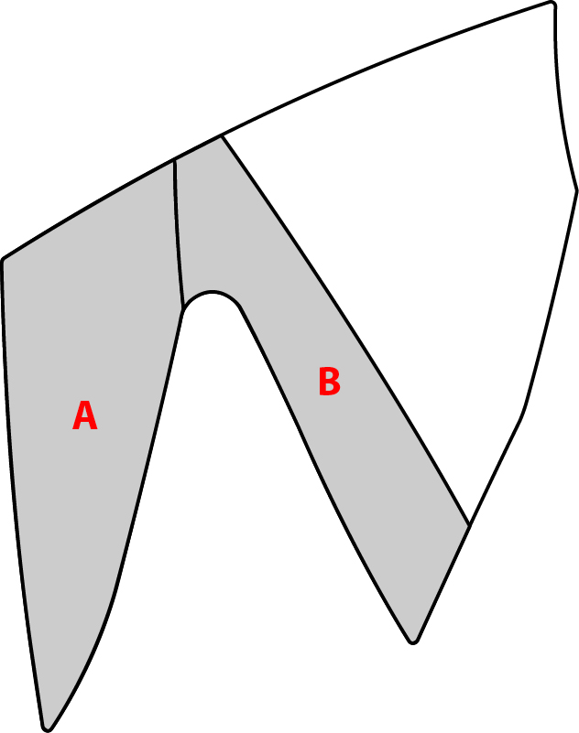
- Apply downward and outward tension to relieve the wrinkles that occur on the fender’s edge. A combination of this and the last step will relieve the wrinkle in this area.

7. Seal all edges
- This will be necessary after each individual piece. With the “T” shirt material wrapped around the hand, apply heat with the heat gun from 6 to 8 inches away from the vehicle panel. Angle the heat gun to heat the glue side of the material as opposed to the clear coat side. First, apply heat, and then wipe the material edge down with the “T” shirt wrapped hand. The film will be very pliable so take care to not distort the film. This process should be applied to the entire outer edge of the piece to seal the piece completely.

8. Mirror Installation Instructions

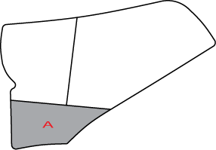
- Line up the corner at the base of the mirror. Squeegee the lower portion down. Be sure to keep the edges within tolerance.

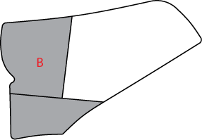
- Pull the material straight up from the corner of Step (a). Work the squeegee up from the corner to the top edge. Make sure to pull the wrinkles out that will occur in the lower front corner.

- Pull the remaining material with only enough tension to pull out the wrinkles along the top side. Use the squeegee to tack down the lower edge. Follow with upward strokes to tack down the top.

- Check the surface for bubbles or any other defects before continuing.

9. Seal all edges.
- This will be necessary after each individual piece. With the “T” shirt material wrapped around the hand, apply heat with the heat gun from 6 to 8 inches away from the vehicle panel. Angle the heat gun to heat the glue side of the material as opposed to the clear coat side. First, apply heat, and then wipe the material edge down with the “T” shirt wrapped hand. The film will be very pliable so take care to not distort the film. This process should be applied to the entire outer edge of the piece to seal the piece completely.

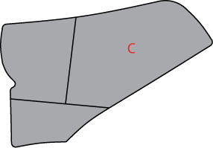
10. Post-Installation.

- Clean the surface of the vehicle as necessary.

11. Removal Process.

- Pick an edge corner of the material up. Grab enough material to allow a secure grasp with hand.

- Pull the material towards the body at an angle (between 30° to 45°). Do not try to rip the material off the surface, instead, stretch the material off the surface. Stretching the material will minimize the amount of adhesive left on the surface.

Accessory Function Checks
Correct part number has been installed.
Proper equipment was used to install.

Check for film quality and proper installation.

Vehicle Function Checks

Vehicle Appearance Check
After accessory installation and removal of protective cover(s), perform a visual inspection.

Verify part number on package.
Check for loose edges, bubbles, and or film damage.
Check for scratches, correct edge alignment, and or debris under film.

Ensure no damage (including scuffs and scratches) was caused during the installation process.
(For PPO installations, refer to TMS Accessory Quality Shipping Standard.)

